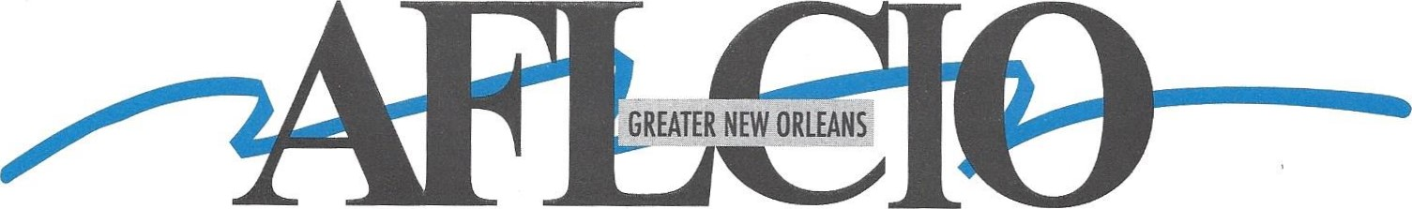
American Federation of Labor • Congress of Industrial Organizations

AFL-CIO EXECUTIVE BOARD MEETING

Date: Thursday, May 22, 2025
Time: 6:00 PM
Location: IBEW Local Union #130
3200 Ridgelake Drive Suite 300
Metairie, LA 70002

Please make every effort to attend.
If you cannot attend,
please send a delegate in your place.
Thank You,
Tiger

2540 Severn Avenue, suite 203 - Metairie, Louisiana 70002 - 504-482-0197 - Fax 504-482-6958
Robert "Tiger" Hammond, Ill — tiger@gnoaflcio.com
Serving Jefferson, Lafourche, Orleans, Plaquemines, St. Bernard, St. Charles, St. John the Baptist and Terrebonne Parishes Since 1901
Robert "Tiger" Hammond, Ill / President Dave Cash / Vice President Chip Fleetwood / Secretary-Treasurer @00046

